INSTITUTE OF COMPUTER TECHNOLOGY
B-TECH COMPUTER SCIENCE ENGINEERING 2025-26
SUBJECT: MICROCONTROLLER & APPLICATION

NAME: Rahul Prajapati
ENRLL. NO: 23162171020
BRANCH: CYBER SECURITY
BATCH: 52
PRACTICAL_7
Aim:- Learning to Interface Seven Segment Displays with 8051.
- Write a sample program to send some data on Seven Segment Displays.
And prepare the hardware module on ISIS Proteus software, test it and then implement on physical hardware. Load the hex file prepared for the sample program in both, proteus and physical hardware and verify your logic whether it’s working or not.

CODE:
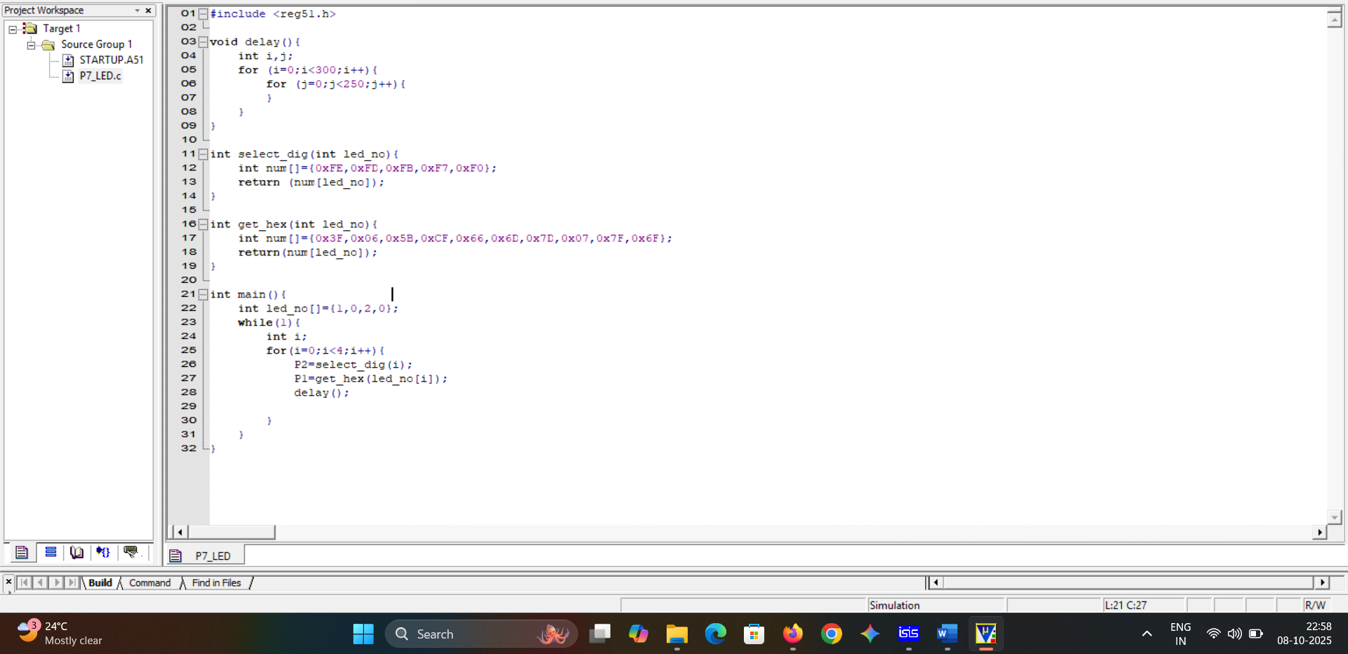

- SIMULATION: To see animation click on image.

CONCLUSION:
In this practical, We understood the process of creating a HEX file from C code in Keil, loading it into Proteus, and simulating real hardware behavior by simulating 7 segment led. This helped us practically understand 8051 programming, data handling, and hardware interfacing concepts.

